OUTPUT FOR ASSIGMENT-1

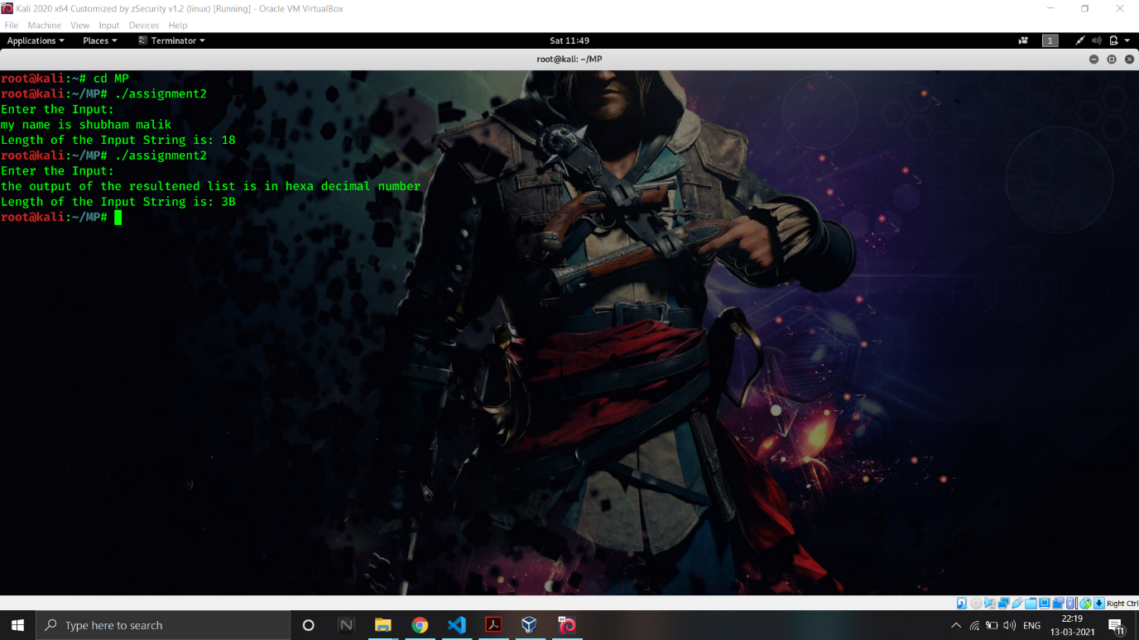Assembly program to Display the **length** of the **Input string**